Introduction To Computer Science Theory 2123
pp. 54-56, Nos. 2, 12, 13, p. 62, Nos. 1, 3, pp. 68-69, Nos. 1,
For question (1) use the Pair Table method.

2) Find a DFA that accepts the language defined by the NFA in fig 2.8
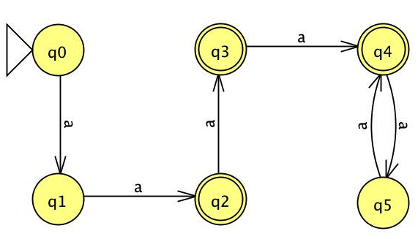

3) Design a NFA with no more than five states for the set { abab^n : n >= 0 } u { aba^n : n >= 0 }
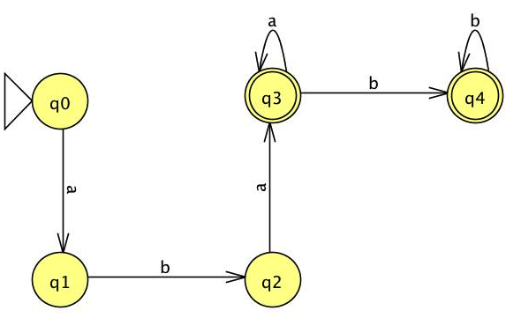

12) Which of the following strings 00, 010001, 10010, 000, 0000 are accepted by the following NFA.
Input | Output
00 | Reject
010001 | Accept
10010 | Reject
000 | Accept
0000 | Reject
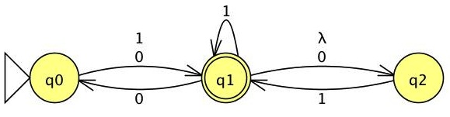

13) What is the complement of the language accepted by the NFA in fig 2.10?
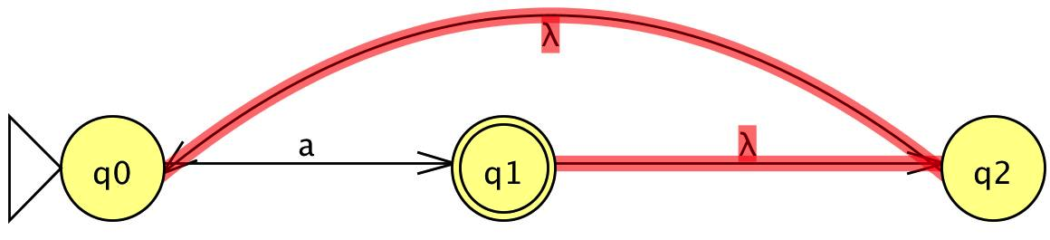
L =

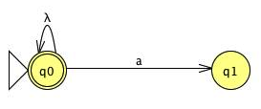
$\overline{L}$ =

Where aεL and a$∉\overline{L}$


- Use the construction from the theorem 2.2 to convert the NFA in fig 2.10 to a DFA.

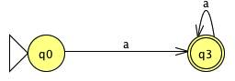
q0 $≡$ q1 $≡$ q2, which means that q0,q1, and q2 are indistinguishable. Therefore, they are equivalent and we only have to choose one transition; which in this case is q0, as shown below.
NFA Transition Table
Q | a | λ
q0 | q1 | -
q1 | - | q2
q2 | - | q0

Can you see a simpler answer more directly?
Transition Table without λ
Q | a
q0 | q1q2q0
q1 | q1q2q0
q2 | q1q2q0
q1q2q0 | q1q2q0

Yes, it is quite obvious that the NFA is only accepting a, and looping on a. Therefore an optimum solution, from first sight, would be:

3) Convert the following nfa into AN equivalent DFA.


NFA

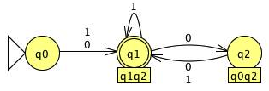

DFA

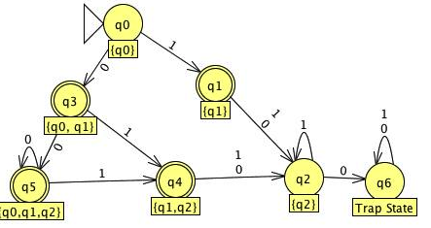
1) Minimize the number of states in the DFA in figure 2.16. Use the Pair Table Method

Pair Table Method
Q | 0 | 1
q0 | q0q1 | q1
q1 | q2 | q2
q2 | $$∅$$ | q2
q0q1 | q0q1q2 | q1q2
q1q2 | q2 | q2
q0q1q2 | q0q1q2 | q1q2

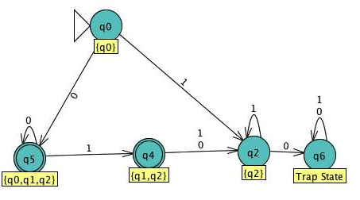

Pair Table Method
Q | 0 | 1
q0 | q0q1 | q1
q1 | q2 | q2
q2 | $$∅$$ | q2
q0q1 | q0q1q2 | q1q2
q1q2 | q2 | q2
q0q1q2 | q0q1q2 | q1q2

$$√$$
$√$

q1 $≡$ q1q2, which means that q1, and q1q2 are indistinguishable. Therefore, they are equivalent and we only have to choose one transition; which in this case is q1q2. The same happen for the states q0q1 and q0q1q2; since q0q1 $≡$ q0q1q2, I only picked q0q1q2 as shown above.

